**WEEK – 6**

**MANDATORY HANDS-ON – React**

1. **Hands-on: 1. ReactJS-HOL**

**Project Name: myfirstreact**

**Step-by-Step Instructions:**

1. **Step 1: Install Create React App globally (optional)**

Open Command Prompt and run:

npm install -g create-react-app

1. **Step 2: Create a new React app named myfirstreact**

Run the following command:

npx create-react-app myfirstreact

1. **Step 3: Move into the app directory**

cd myfirstreact

1. **Step 4: Open the project in Visual Studio Code**

code .

1. **Step 5: Modify App.js**
2. **In VS Code, expand the src folder.**
3. **Open the App.js file.**
4. **Delete all the existing code.**
5. **Replace it with the following:**

import React from 'react';

function App() {

  return (

    <div>

      <h1>Welcome to the first session of React</h1>

    </div>

  );

}

export default App;

1. **Step 6: Run the application**

In the terminal (inside the myfirstreact folder), type:

npm start

**This will:**

* Start the React development server.
* Automatically open your browser at:  
  ➤ <http://localhost:3000>

1. **OUTPUT:**

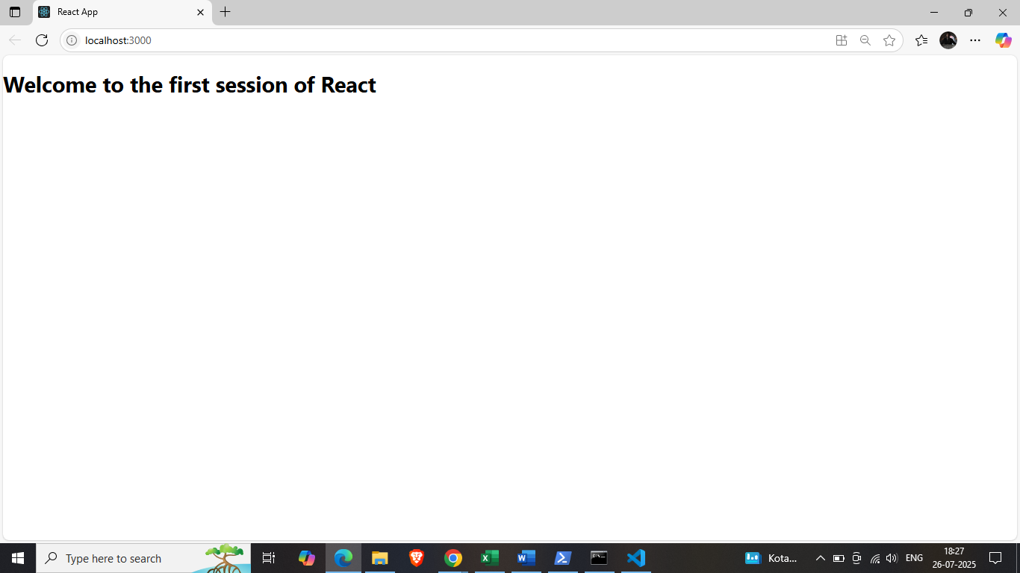

1. **Hands-on: 2. ReactJS-HOL**

**Project Name: studentapp**

**Step-by-Step Instructions**

1. **Step 1: Create a React App**

Open **VS Code terminal** or **Command Prompt** and run:

npx create-react-app StudentApp

1. **Step 2: Create Components folder**

Inside src folder:

1. Right-click on src → **New Folder** → Name: Components
2. Inside Components, add 3 new files:
   * Home.js
   * About.js
   * Contact.js
3. **Step 3: Code for Home.js**

import React from 'react';

class Home extends React.Component {

  render() {

    return (

      <div>

        <h2>Welcome to the Home page of Student Management Portal</h2>

      </div>

    );

  }

}

export default Home;

1. **Step 4: Code for About.js**

import React from 'react';

class About extends React.Component {

  render() {

    return (

      <div>

        <h2>Welcome to the About page of Student Management Portal</h2>

      </div>

    );

  }

}

export default About;

1. **Step 5: Code for Contact.js**

import React from 'react';

class Contact extends React.Component {

  render() {

    return (

      <div>

        <h2>Welcome to the Contact page of Student Management Portal</h2>

      </div>

    );

  }

}

export default Contact;

1. **Step 6: Modify App.js to call all components**

Open src/App.js and replace the code with:

import React from 'react';

import Home from './Components/Home';

import About from './Components/About';

import Contact from './Components/Contact';

function App() {

  return (

    <div>

      <Home />

      <About />

      <Contact />

    </div>

  );

}

export default App;

1. **Step 7: Run the App**

In terminal, type:

npm start

**8. Step 8: Open in Browser**

* Open your browser.
* Visit: <http://localhost:3000>

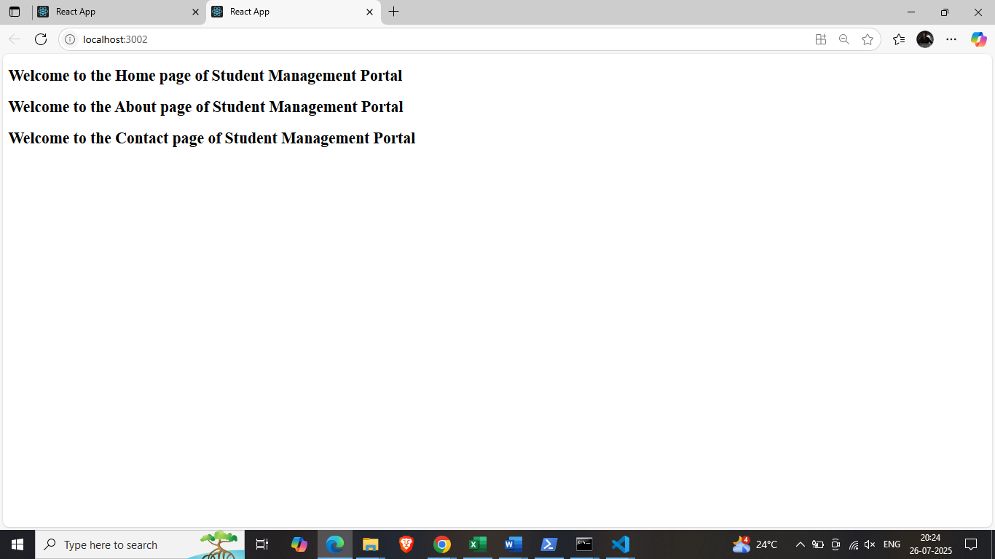

1. **Hands-on: 3. ReactJS-HOL**

**Step 1: Create the React App**

Open Command Prompt and run:

npx create-react-app scorecalculatorapp

This creates the project folder with all necessary React files.

**Step 2: Change the Port to 3005**

1. Go to the project folder:

cd scorecalculatorapp

1. Create a new file named .env inside the scorecalculatorapp folder.
2. Add this line to the .env file:

PORT=3005

This tells React to run the app on **port 3005** instead of 3000.

**Step 3: Open the Project in VS Code**

code .

**Step 4: Create a Folder for Components**

1. Inside the src folder, create a new folder named:

Components

1. Inside Components, create a new file named:

CalculateScore.js

**Step 5: Add Code to CalculateScore.js**

Paste this code:

import React from 'react';

import './Stylesheets/mystyle.css';

//import '../Stylesheets/mystyle.css'; // ✅ Make sure this path is exactly correct

function CalculateScore(props) {

  const average = props.Total / props.Goal;

  return (

    <div className="score-card">

      <h2>Student Score Calculator</h2>

      <p><strong>Name:</strong> {props.Name}</p>

      <p><strong>School:</strong> {props.School}</p>

      <p><strong>Total Marks:</strong> {props.Total}</p>

      <p><strong>Number of Subjects:</strong> {props.Goal}</p>

      <p className="average"><strong>Average Score:</strong> {average}</p>

    </div>

  );

}

export default CalculateScore;

**✅ Step 6: Create a Folder for CSS Styles**

1. Inside the src folder, create a new folder named:

Stylesheets

1. Inside Stylesheets, create a file named:

mystyle.css

1. Add the following CSS code to mystyle.css:

.score-card {

  border: 2px solid #4CAF50;

  padding: 20px;

  border-radius: 10px;

  background-color: #f9f9f9;

  width: 400px;

  margin: 30px auto;

  font-family: Arial, sans-serif;

}

.score-card h2 {

  color: #4CAF50;

  text-align: center;

}

.average {

  font-weight: bold;

  color: blue;

}

**Step 7: Edit App.js to Use the Component**

Open src/App.js and replace all the code with:

import React from 'react';

import './App.css';

import CalculateScore from './Components/CalculateScore';

function App() {

  return (

    <div className="App">

      <CalculateScore Name="Charitha" School="ABC High School" Total={450} Goal={5} />

    </div>

  );

}

export default App;

**Step 8: Run the React App**

In the terminal, inside the project folder, type:

npm start

Your browser will automatically open:

<http://localhost:3005>

**OUTPUT:**

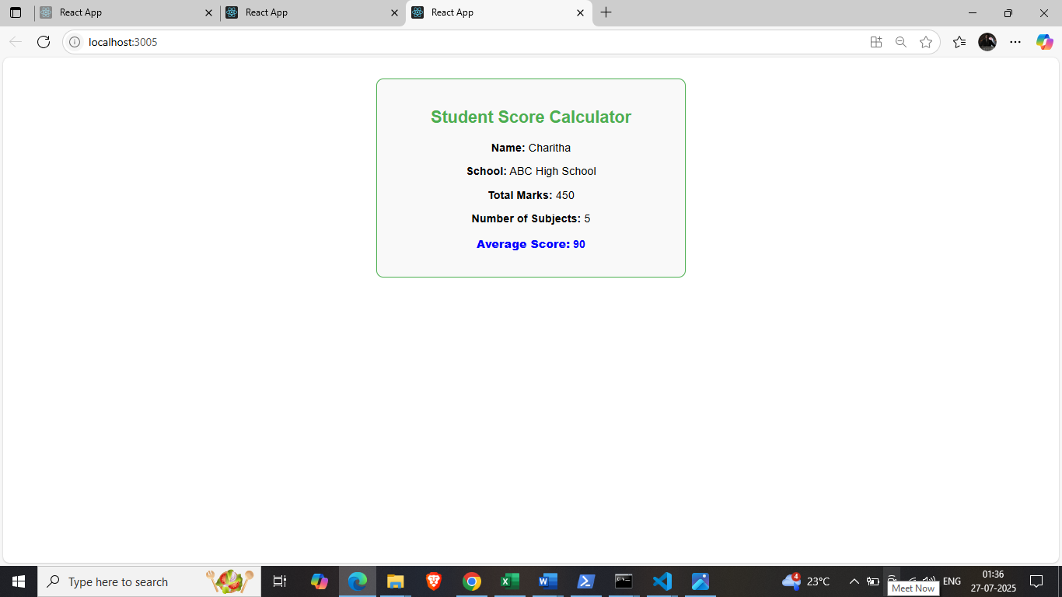

**4) Hands-on: 4. ReactJS-HOL**

**Step by Step Instructions**

**1) Create React App from Terminal:**

npx create-react-app blogapp

**2) Create Post.js file in src**

In VS Code:

* Go to src folder
* Right-click → **New File** → Name it Post.js

import React from 'react';

class Post extends React.Component {

  render() {

    const { title, body } = this.props;

    return (

      <div style={{ border: "1px solid gray", margin: "10px", padding: "10px" }}>

        <h2>{title}</h2>

        <p>{body}</p>

      </div>

    );

  }

}

export default Post;

**3) Create Posts.js file in src**

* Again in src folder
* Right-click → **New File** → Name it Posts.js

import React from 'react';

import Post from './Post';

class Posts extends React.Component {

  constructor(props) {

    super(props);

    this.state = {

      posts: [],

      hasError: false

    };

  }

  loadPosts = () => {

    fetch("https://jsonplaceholder.typicode.com/posts")

      .then(response => response.json())

      .then(data => {

        this.setState({ posts: data });

      })

      .catch(error => {

        console.error("Error fetching posts:", error);

      });

  };

  componentDidMount() {

    this.loadPosts();

  }

  componentDidCatch(error, info) {

    this.setState({ hasError: true });

    alert("An error occurred in the component!");

    console.error("Error caught:", error, info);

  }

  render() {

    if (this.state.hasError) {

      return <h1>Something went wrong while loading posts.</h1>;

    }

    return (

      <div>

        <h1>All Posts</h1>

        {this.state.posts.map(post => (

          <Post key={post.id} title={post.title} body={post.body} />

        ))}

      </div>

    );

  }

}

export default Posts;

**4) Update App.js to include Posts**

In src/App.js, replace everything with:

import React from 'react';

import Posts from './Posts';

function App() {

  return (

    <div className="App">

      <Posts />

    </div>

  );

}

export default App;

**Output:**

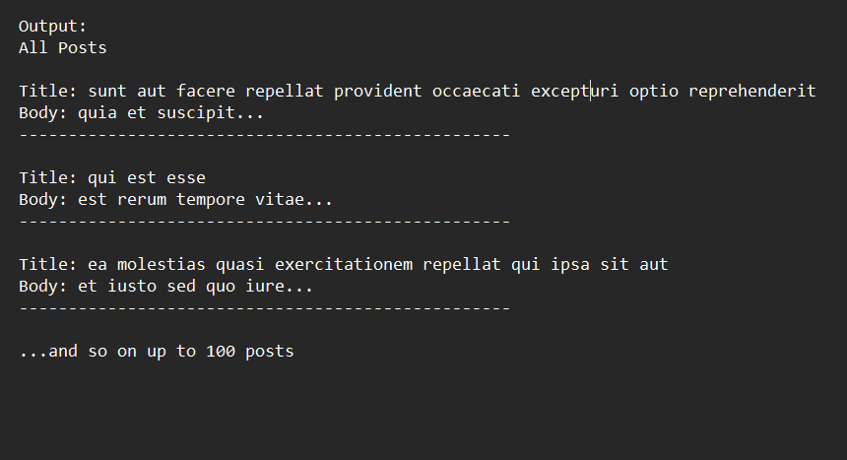

**5) Hands-on: 5. ReactJS-HOL**

**Step by Step Instructions**

**Step 1–3: Setup Project:**

npx create-react-app my-cohort-dashboard

cd my-cohort-dashboard

npm install

**Step 4: Create CSS Module**

Create a file:

src/CohortDetails.module.css

/* Step 6: box class */

.box {

  width: 300px;

  display: inline-block;

  margin: 10px;

  padding: 10px 20px;

  border: 1px solid black;

  border-radius: 10px;

}

/* Step 7: style for <dt> */

dt {

  font-weight: 500;

}

**Step 5–10: Create Component and Use Styling**

Create src/CohortDetails.js

import React from 'react';

import styles from './CohortDetails.module.css'; // Step 8: import CSS module

const CohortDetails = ({ name, trainer, status }) => {

  // Step 10: Conditional inline style for <h3>

  const headingStyle = {

    color: status === 'ongoing' ? 'green' : 'blue'

  };

  return (

    <div className={styles.box}> {/* Step 9: Apply CSS module class */}

      <h3 style={headingStyle}>{name}</h3>

      <dl>

        <dt>Trainer</dt>

        <dd>{trainer}</dd>

        <dt>Status</dt>

        <dd>{status}</dd>

      </dl>

    </div>

  );

};

export default CohortDetails;

**Step 11: Use the Component in App**

**Modify src/App.js:**

import React from 'react';

import CohortDetails from './CohortDetails';

function App() {

  return (

    <div style={{ padding: '20px' }}>

      <h2>My Academy Dashboard</h2>

      <CohortDetails name="React Bootcamp" trainer="Charitha" status="ongoing" />

      <CohortDetails name="Spring JPA Masterclass" trainer="Arjun" status="completed" />

    </div>

  );

}

export default App;

**Run Your Application:**

npm start

**Output:**

